Cypress Automation Installation

Install IntelliJ IDE

Go to your project path on cmd prompt

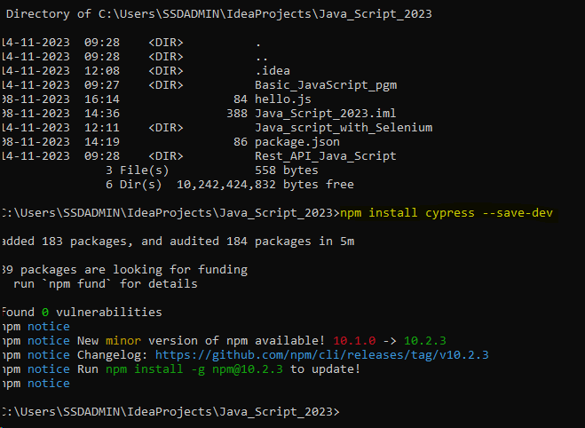

To Open Cypress Dashbaord

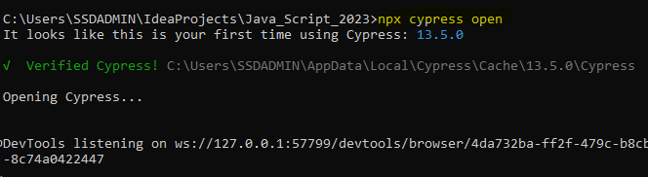

Cypress dashboard board page as below

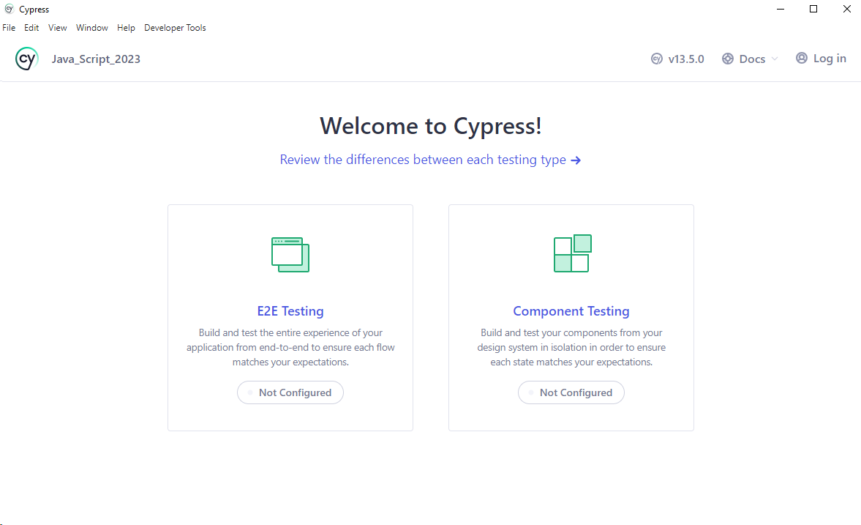

Click E2E Testing

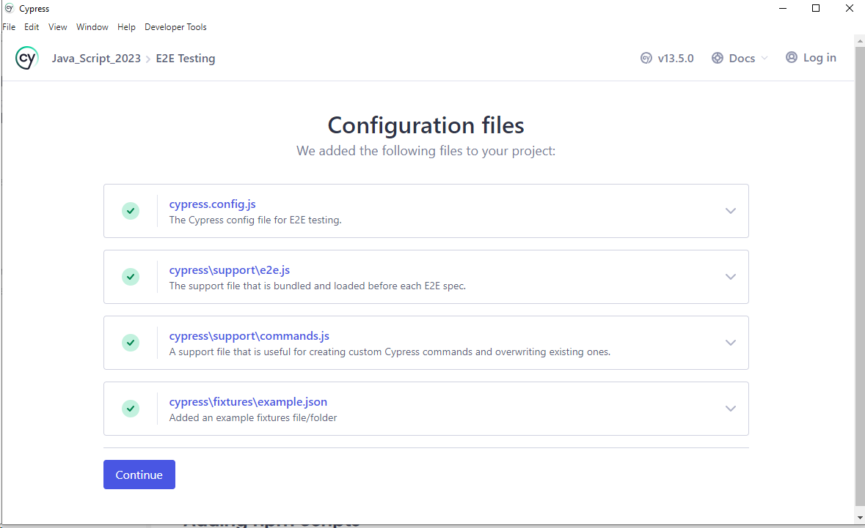

Choose your Browser

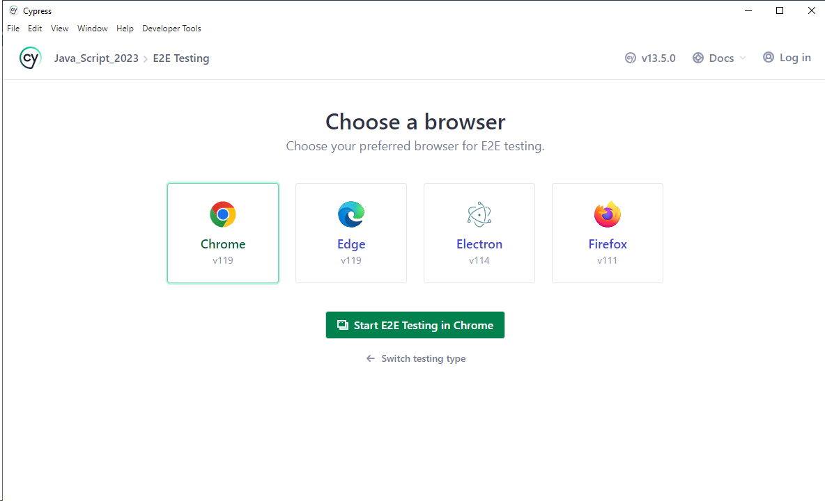

You may get the Test runner after chosen a browser

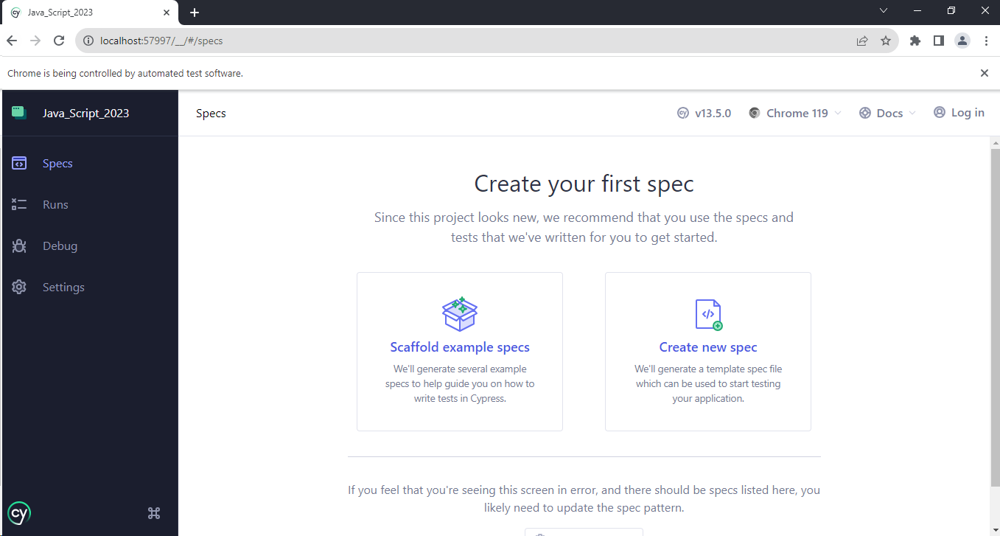

Create the Integration folder under the Cypress folder as suggested by the Cypress team

Create one subfolder to keep to project code

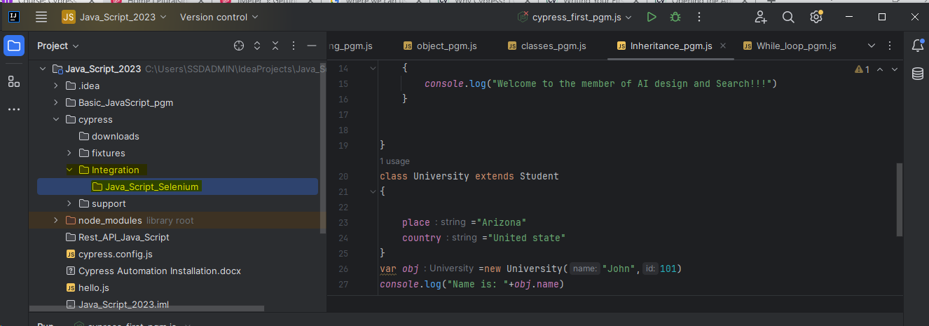

Open the Cypress. config.js file and enter your folder path as mentioned on below

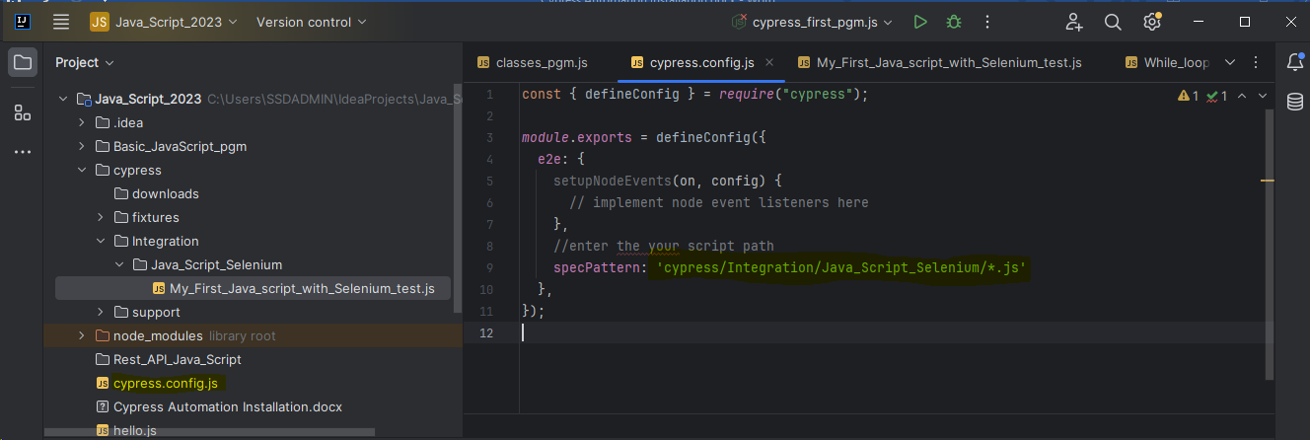

You can able to see your created test file on the Cypress dashboard

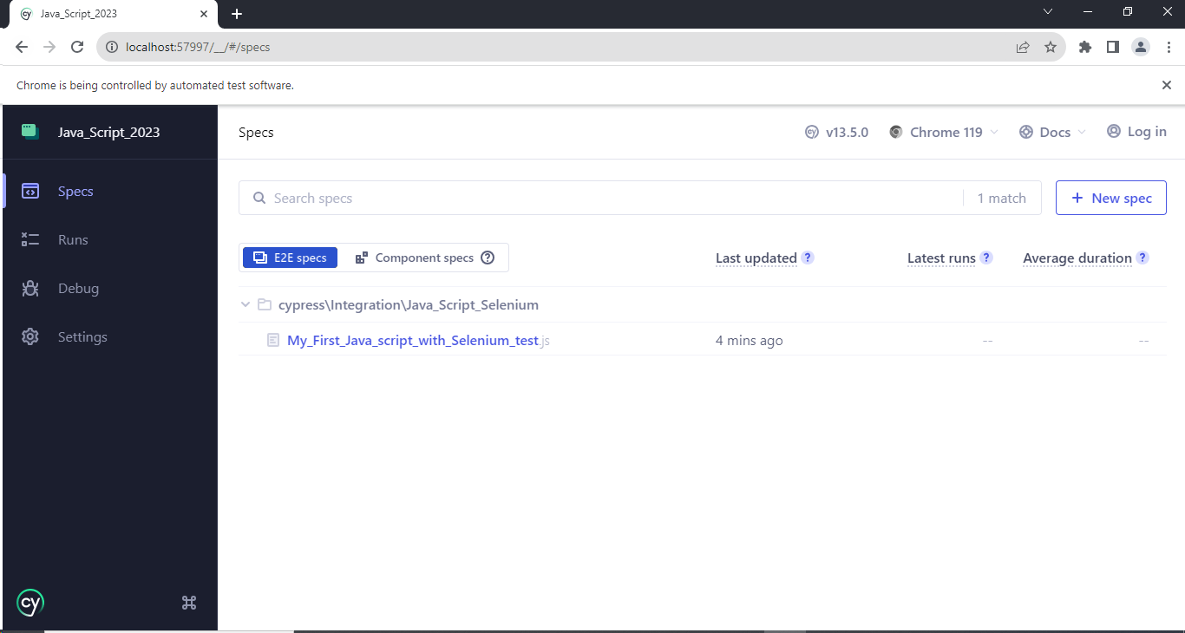

Example of cypress automation code

*describe*("My first testsuite",function ()  
{  
 *it*("My first testcase",function (){  
 //visit method used to visit any website  
 *cy*.visit("http://www.automationpractice.pl/index.php")  
   
 })  
  
})

Cypress Test Runner execution Results

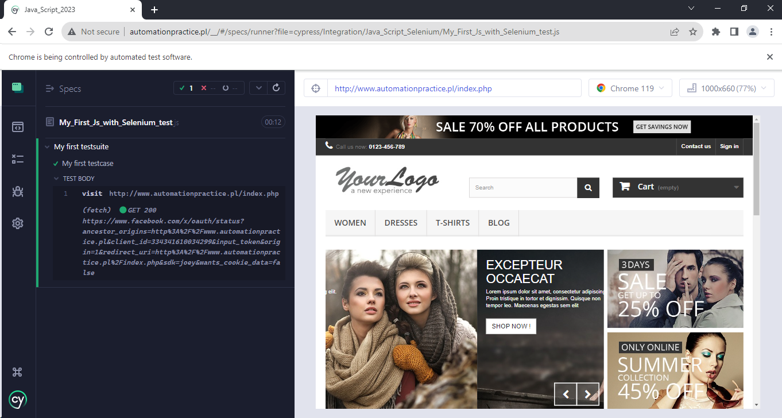

Click Spec to Return back to Test Runner

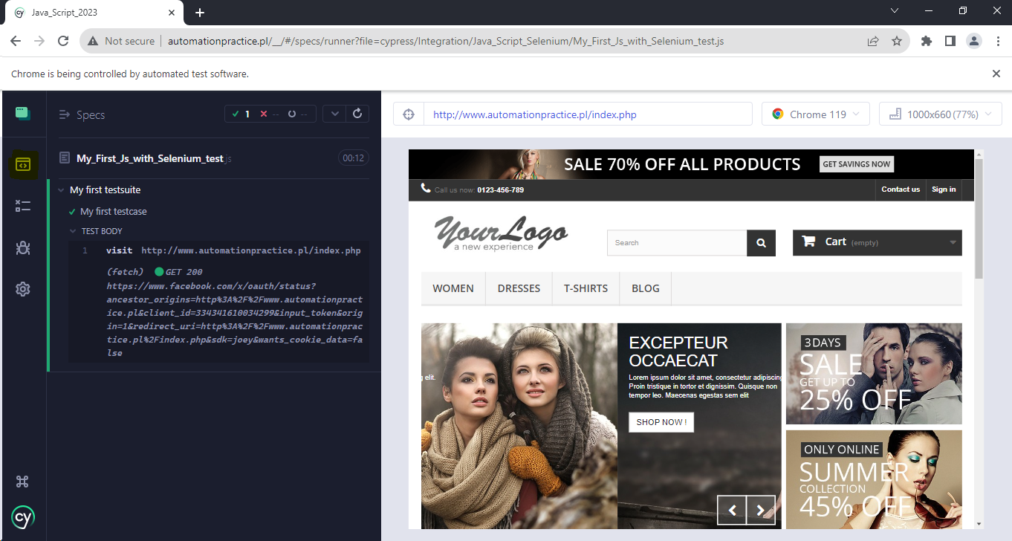

Command prompt Execution Results

To execute the script in headless mode



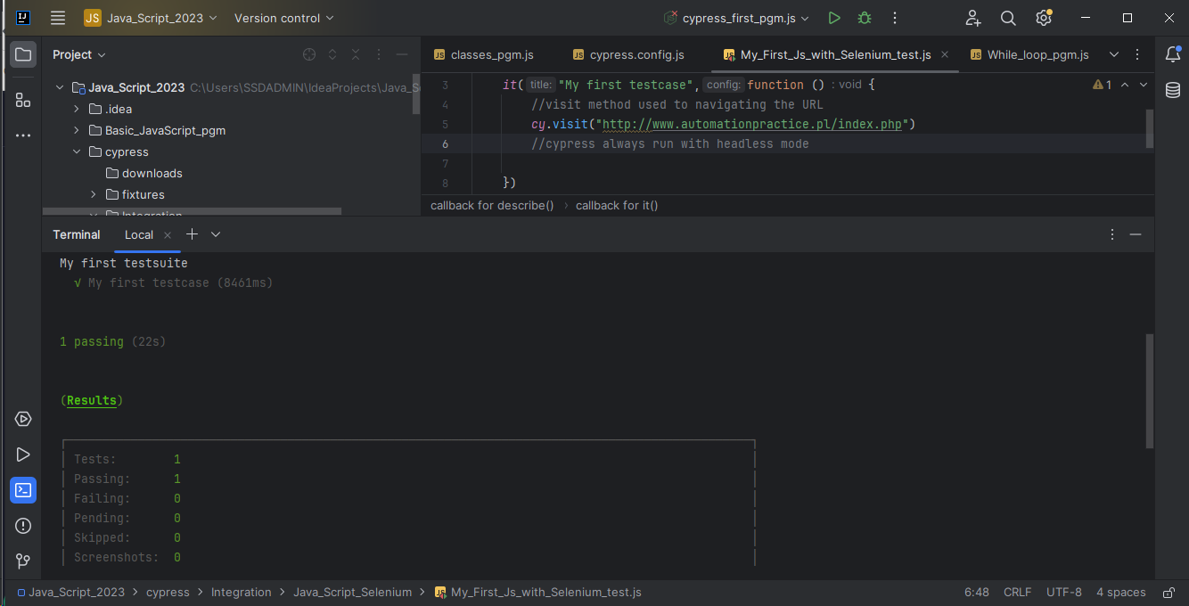

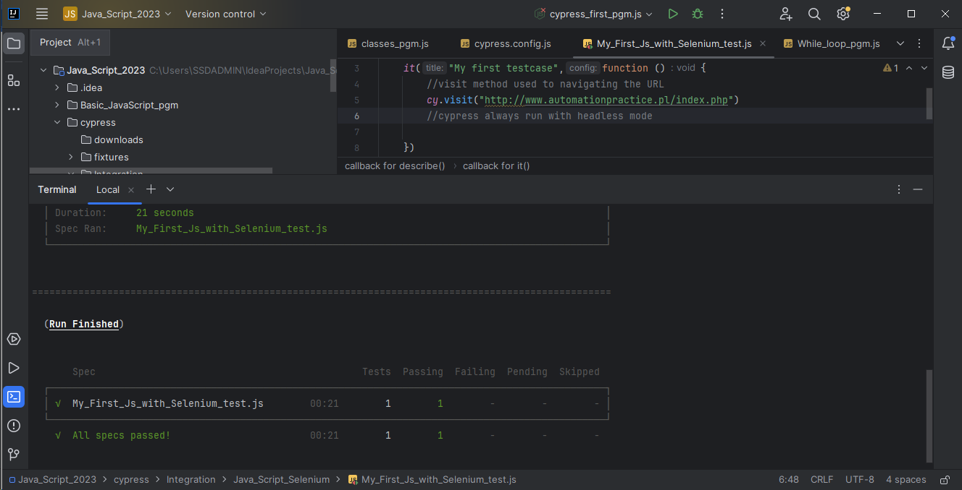

To execute the script in headed mode

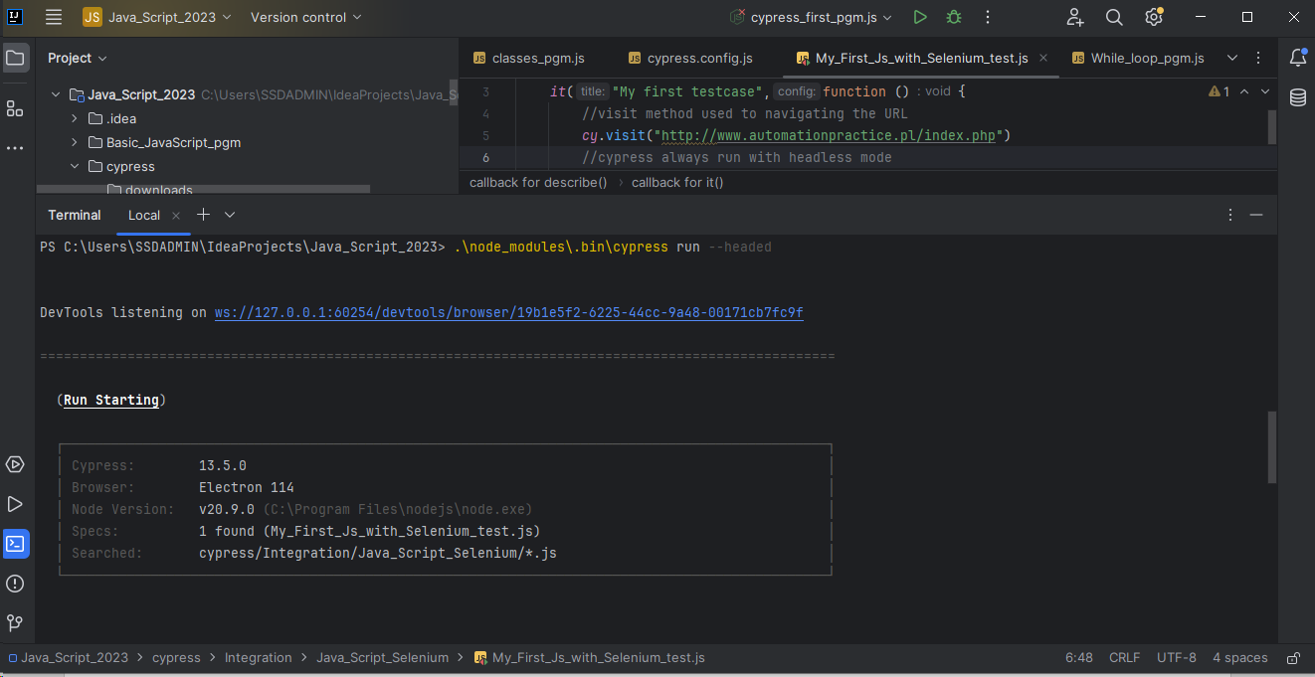

To execute the script in chrome



//Execution Results

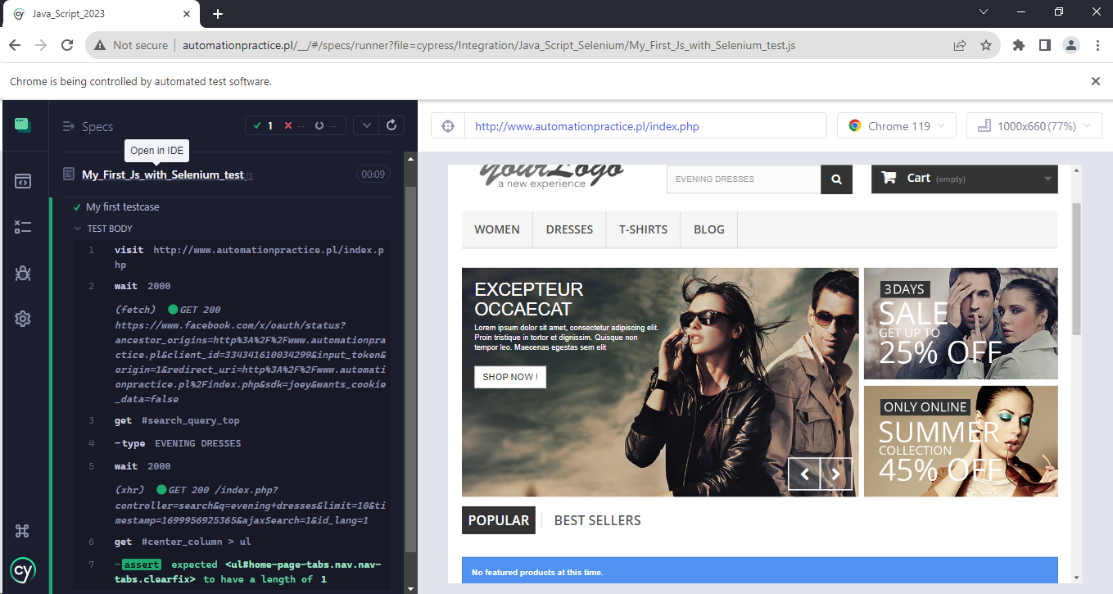

**Cypress BDD installation Steps**

**npm install --save-dev cypress-cucumber-preprocessor**

